 | 7.1.16 Editors - 3D Viewport - Header - Mesh - Sculpt mode - Face Sets menu
Table of content
Sculpt Mode - Face Sets Menu 1
Face Sets from Mask 1
Face Sets from Visible 1
Face Sets from Edit Mode Selection 1
Grow Face Sets 2
Shrink Face Sets 2
Expand Face Set by Topology 2
Expand Active Face Set 2
Extract Face Set 2
Initialize Face Sets 2
Randomize Colors 2
Show/Hide submenu 2
Toggle Visibility 3
Show all Geometry 3
Hide Active Face Set 3

Sculpt Mode - Face Sets Menu
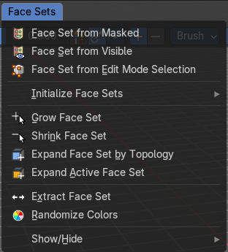
Face Sets is a kind of a mask that shows in different colors to assist in sculpting regions and running different sculpt brush effect. The colors are random.
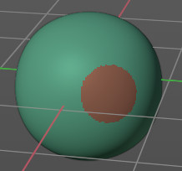

In the Face Sets menu you can create and manage Face Sets.

Face Sets from Mask
Creates a face set from the current mask.

Face Sets from Visible
Creates a face set from the visible geometry.

Face Sets from Edit Mode Selection
Creates a face set from the selection that you do in edit mode.

Grow Face Sets
Grows the face sets.

Shrink Face Sets
Shrinks the face sets.

Expand Face Set by Topology
Expands a face set from a starting point on the topology. Click and drag on the mesh once you start the operator.

Expand Active Face Set
Expands a face set from the active face set under the mouse cursor. Click and drag on the face set once you start the operator.

Extract Face Set
Creates a new mesh object from the selected face set. The mouse turns into a color picker to pick the face set when you activate this too.

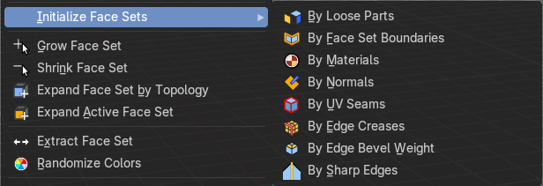
Initialize Face Sets
A menu with various methods to initialize the face sets. These methods include the following:
- By Loose Parts
- By Face Set Boundaries
- By Materials
- By Normals
- By UV Seams
- By Edge Creases
- By Edge Bevel Weight
- By Sharp Edges

Randomize Colors
Generates a new set of random colors to render the face sets.

Show/Hide submenu
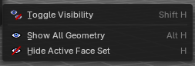
Note that these operators are best used by Hotkey. When you use them from the menu then you need to confirm the action by a mouse click. You will see a corresponding warning in the header.
You need to click at the face set that you want to hide. Same goes for the toggle. Toggle is meant for the case that you have two or more face sets. And then it toggles between the invisible and the face set that you click at.
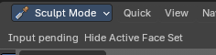

Toggle Visibility
Toggles the visibility of the active face set.

Show all Geometry
Reveals all hidden geometry.

Hide Active Face Set
Hides the active face set.

